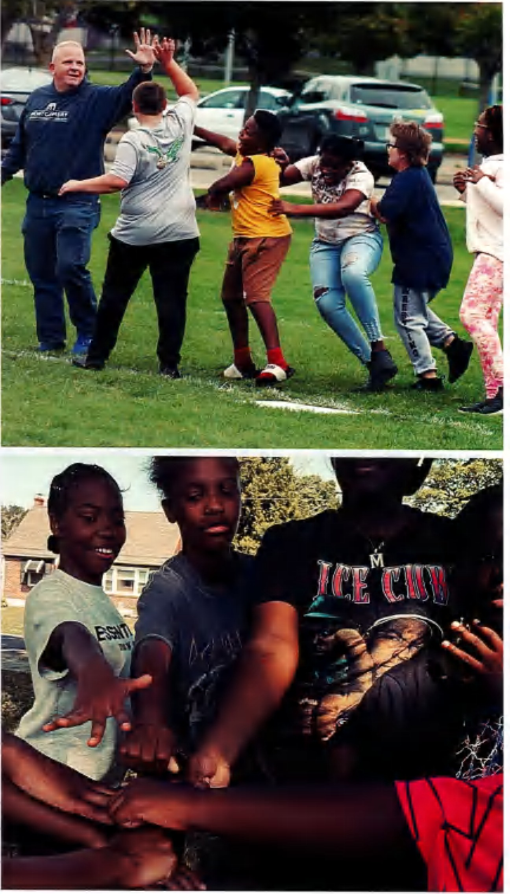

Community Mentor Program

Make a difference in the life of a Pottstown Middle School Student!
When & Where?
- 30 Minutes 1x/wk / same day same time each week
- Pottstown Middle School
- During student's lunch or 7:50 am-8:30 am
Who?
Committed Adult Community Members

What?
  - Show up
  - Talk, listen, encourage
  - Provide shared lunch 2x/mo
  - Commit to mentoring for at-least 1 school year or longer

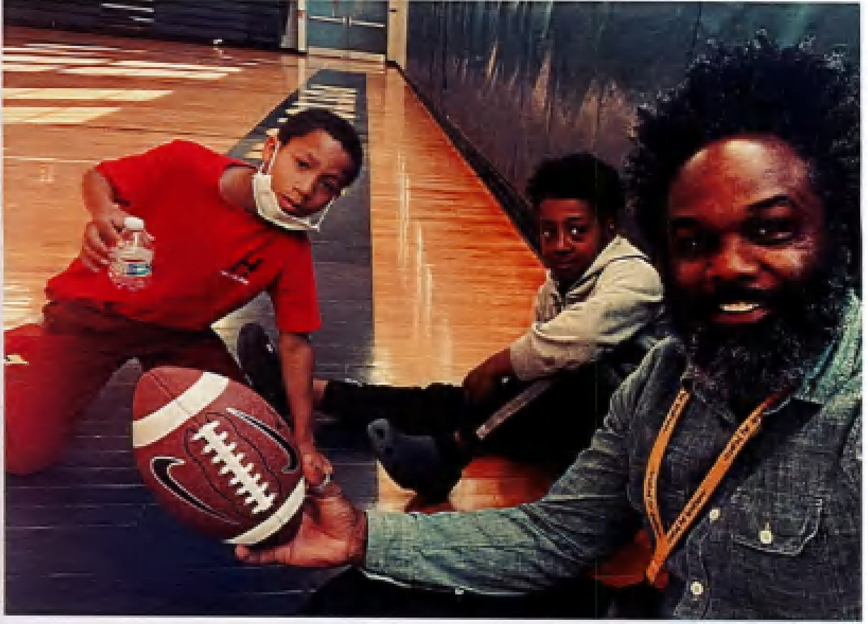Interested in Being a Ment or?
==-
Join The STRIVE Initiative to create positive community connections. You are invited to our training for Created for Greatness, the community-based mentoring program at Pottstown Middle School.
Learn about specific ways you can get
involved in the community to make a lasting impact! Community-based

Time: 6:30pm - 7:45pm

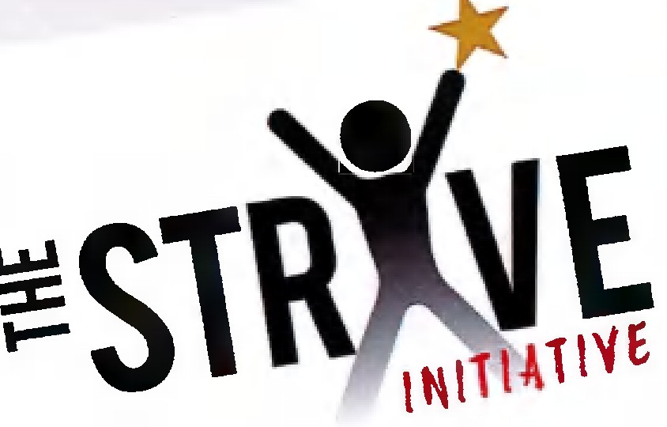
mentorship allows young people to develop lasting relationships with caring adults, creating a generation of middle school students who are connected to their community, feel self-confident, and· know they are not alone.
Montgomery County Community College
West Campus - North Hall Gallery, 2nd Floor
101 College Drive
Pottstown, PA 19464 (there is construction/ you will need to walk through underpass from parking lot)

Light refreshments will be served courtesy of Ice
House Steaks & Pizza

David Charles, Program Coordinator
215.738.2425
dcharles@striveinitiative.org

